**COURSKWORK**

Table Of Contents

Part 1: Project planning case study 4

1) Requirement specification 4

1) Scope 4

2) Functional Requirements 4

3) Non-functional Requirements 4

Design work: 5

Use case Diagram: 5

Class Diagram: 6

Planning 7

CoCoMo Model 7

Social, Legal and Ethical review of the project 8

Part 2: Management report 8

Process description and quality control 8

Review on quality assurance procedures 9

Conclusion 9

Time Management 9

References 10

Part 3: Academic essay 10

Abstract 11

Introduction 11

Discussion 11

Conclusion 16

References 16

Part4: Group Performance Evaluation 17

**Table Of Figure**

Figure 1 Use Case Diagram 5

Figure 2 Class Diagram 6

Figure 3 Gantt Chat 7

# Part 1: Project planning case study

## Requirement specification

### Scope

The aim of this project is to develop a centralised fully automated system of the sterilization process for the hospital which is previously done on paper. It will help the hospital to track all the instruments used in the surgery for a specific patient. It will build a complete history of a patient and the surgical instrument which is used for that patient.

### Functional Requirements

1. User should (Login, Registration)
2. Each tray will be recorded by a unique id.
3. Surgical instruments will be tracked by the tray id it is placed in.
4. Tray will also be tracked for what medical procedure is it used for.
5. System will record the sterilization process each time the tray and instruments go through by their id.
6. If any instrument is disposed from a tray after sterilization process system will track that and the new instrument added will also be tracked.
7. Date and time for the sterilization process will be recorded for each tray and each time it will gone through the process.
8. The person used the tray will also be tracked by unique id and name.

### Non-functional Requirements

1. The proposed system should be able to integrate with other hospital information system.
2. Security will be considered as a top priority.
3. Reliability

The reliability of the program depends on the reliability of the separate components. The main pillar of reliability of the system is the backup of the database which is continuously maintained and updated to save the most recent changes. So, the overall stability of the system depends on the reliability of container and its underlying system.

1. Availability

The system should available at all times, the user can access it anytime. It is only restricted by the down time of the server on which the system runs.

## Design work:

### Use case Diagram:

It depicts the process of the working model.

## 

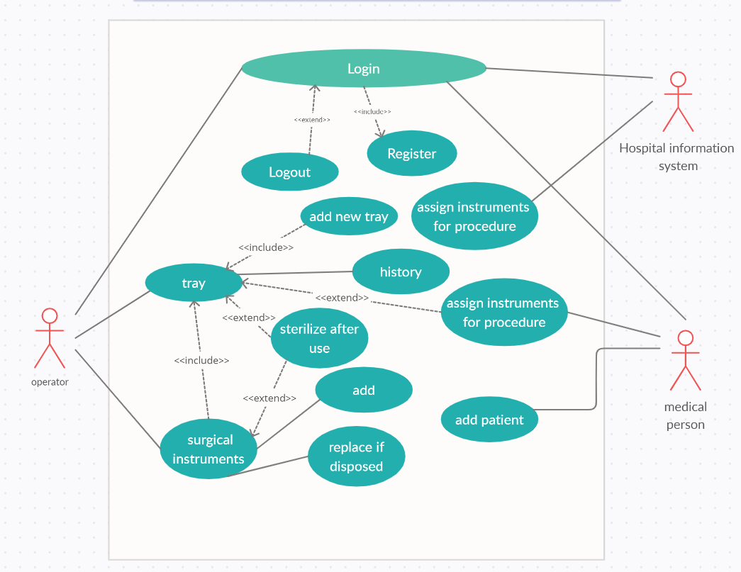

Figure 1 Use Case Diagram

### Class Diagram:

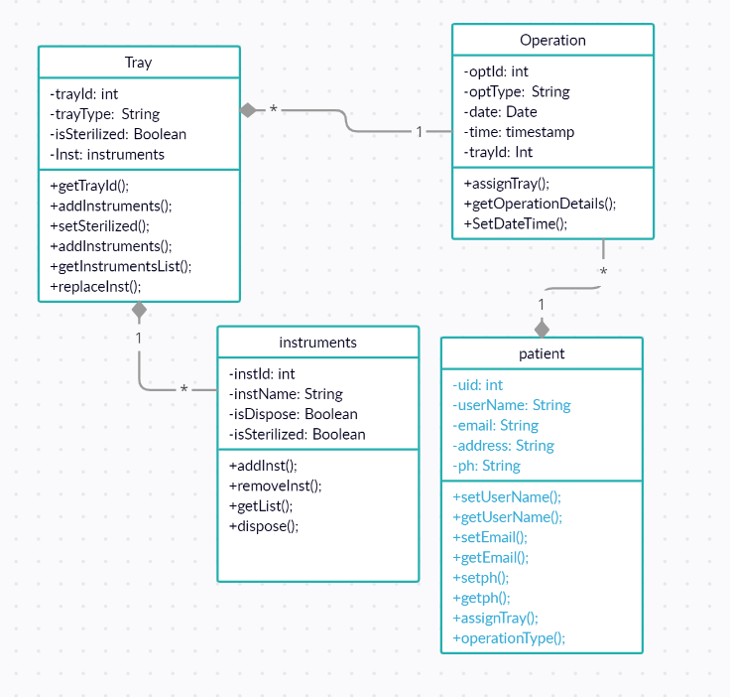

Figure 2 Class Diagram

## Planning

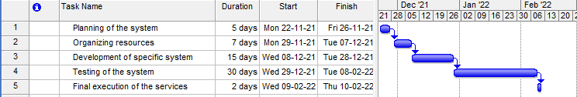

Figure 3 Gantt Chat

## CoCoMo Model

CoCoMo model is used to estimate the cost, effort and time use for the development of a specific software. To get an estimate the number of lines is expected are 400 KLOC.

E = $a_{b}{ (KLOC)}^{b_{b}}$

D = $c_{b }$ ${ (KLOC)}^{d_{b}}$

In Organic, E = 2.4 ${(400)}^{1.805}$ = 1295.31 PM

D = 2.8 ${(1291.31)}^{0.38}$ = 38.07 PM

Semi-embedded, E= 3.0 ${(400)}^{1.2}$ = 2462.29 PM

D = 2.5 (2462.79) = 38.45PM

Embedded, E= 3.6 ${(400)}^{1.20}$ = 4772.81 PM

D = 2.5 (4772.81) = 38.45 PM

## Social, Legal and Ethical review of the project

The planning process is carried out based on social standards so that every segment of society can access the services. Regarding the legal procedure, the implemented services should be certified. Logical reviews need to be collected from the user as all the implemented services are done to make the process effective and convenient.

# Part 2: Management report

## Process description and quality control

Quality management and control process in case of a sterilization process of a hospital is to be created based on the activities along with the involved factors (Swetha *et al.* 2019). Quality of the services is managed in multiple steps and that includes:

* ***Identification of goal*** - the goal here is to provide good and sterilized medical services to the patients and that will ensure security regarding the transmission of diseases.
* ***Identification of success factors* -** critical success factors are associated with the activities consisting of providing equipment at need and maintaining them for further uses.
* ***Feedback and rectification*** - Feedback from the patients is to be collected as they can provide the details of the scenario and based on the provided feedback, services need to be improved.
* ***Implementation of improvements*** - Improvements such as better cleaning and sterilization, a proper hospital management system along with the implementation of quality management software.
* ***Implementation of Quality management software*** - Quality management software acts like a logbook that holds all the details regarding the provided services (Aminizadeh *et al.* 2019). Good quality management and assurance software platforms are to be implemented such as TRACKMEDIUM, as this is an ISO 9001 certified platform.

## Review on quality assurance procedures

The quality management procedures involve of the actions that are actuality conducted in order to uphold the quality. This method will be performed in numerous steps and it contains:

* ***Big data testing*** - Healthcare services are comprehensive and data centric as details of the patient can be required at any moment (Bahadori *et al.* 2018). Organizing the patient's data will be done by the execution of the Big data solutions.
* ***Application security*** - Privacy of data will be maintained as these are confidential information and may impact the patient if it is not held wisely.
* ***The functionality of the used software*** - Use of IoT software and platforms are needed and the operation and its functionality are to be examined as this should be flexible as well as versatile in nature in storing all details.
* ***Interoperability of devices*** - Modern healthcare services are carried out with accessing different devices in multiple gadgets and their interoperability is to be looked for smoother services.
* ***Testing for usability*** - The usability of the applied platforms is to be checked as based on these records, the patients will be treated.

## Conclusion

A brief discussion on the quality management system in healthcare is studied in the assignments along with the addition of implementation of software. The details, as well as planning for software and monitoring process, have been described in brief in the task.

### Time Management

First, we have to break down the requirements into smaller tasks and then implement it one by one. Before implementing we have to priorities the requirements that are necessary for the project.

For the project the functional requirements are considered as top priority. So, to implement these requirements we need to further divide it into sub tasks.

Top priority tasks will be given 70% of the time from then overall time estimation and other 30% time will be given for testing and deployment purpose.

## References

Aminizadeh, M., Farrokhi, M., Ebadi, A., Masoumi, G.R., Kolivand, P. and Khankeh, H.R., 2019. Hospital management preparedness tools in biological events: a scoping review. Journal of education and health promotion, 8.

Bahadori, M., Teymourzadeh, E., Faizy Bagejan, F., Ravangard, R., Raadabadi, M. and Hosseini, S.M., 2018. Factors affecting the effectiveness of quality control circles in a hospital using a combination of fuzzy VIKOR and Grey Relational Analysis. *Proceedings of Singapore Healthcare*, *27*(3), pp.180-186.

Swetha, K.N., Sathish Raju, N., Doddamani, P. and Suma, N.M., 2019. Quality assurance program in clinical biochemistry laboratory at a multispeciality teaching hospital, with special reference to quality indicators. *Natl J Lab Med*, *8*.

# Part 3: Academic essay

TOGAF

wajahat Ali Mughal, Msc Computer Science, wm9398d@gre.ac.uk

## Abstract

The Open Group Architecture Framework (TOGAF) is a framework for building architectures. Using this tool, you may create the perfect architecture for your business.

## Introduction

The Open Group Architecture Framework (TOGAF) is a framework for designing corporate architecture that includes a logical model, a thorough approach, and a collection of supporting tools. It may be utilised by any company that wants to design an enterprise architecture.

Members of The Open Group's Architecture Forum worked together to create TOGAF. TAFIM, the Technical Architecture Framework for Information Management (TAFIM) published by the US Department of Defence in 1995, served as the basis for the initial creation of TOGAF Version 1. (DoD). DoD granted The Open Group specific permission and encouragement to construct TOGAF atop the TAFIM, which was the product of years of development work and a substantial investment from the US Government.

Each year, participants of The Open Group Architecture Forum have worked together to produce a new edition of TOGAF, which is then made available on The Open Group website.

## Discussion

The TOGAF paper is divided into four sections:

Part 1 introduces some of the fundamental ideas of enterprise architecture and the TOGAF methodology in particular.

Part II is the heart of the TOGAF framework. Step-by-step instructions on how to build an enterprise architecture are provided in this document.

In the third part (Enterprise Continuum) It explains the TOGAF Continuum, which incorporates the TOGAF Foundation Architectural and the Integrated Information Infrastructure Reference Model virtual library of architecture assets (III-RM).

QUARTER IV

(Resources) TOGAF and the TOGAF ADM may be applied with the help of the TOGAF Resource Base, which is included in this section.

The Open Group Architecture Framework (TOGAF) is a framework for building architectures. Using this tool, you may create the perfect architecture for your business.

When it comes to designing an IT enterprise architecture, TOGAF's ADM (Architecture Development Method) is the most important tool in the box.

As part of an overall corporate architecture, TOGAF is meant to accommodate the following subsets of architecture:

The company strategy, governance, structure, and major business processes are defined by a Business (or Business Process) Architecture.

An organization's logical and physical data assets and data management resources are referred to as a Data Architecture.

This kind of architecture offers a blueprint for the deployment of individual application systems, their interactions, and their connections to the organization's fundamental business processes. It is called an Applications Architecture.

Software and hardware capabilities that are needed to enable business, data, and application services are described in a Technology Architecture (TA). Everything from middleware to networks to processors is included in this category.

To enable mission-critical business applications utilising open systems building blocks, any company doing or preparing to undertake enterprise architecture design and deployment.

In order to reap the advantages of open systems implementation, customers that use TOGAF to develop and execute corporate architectures may be certain that their designs and procurement specifications will considerably assist open systems implementation.

Developing an enterprise architecture using TOGAF is a simple, practical, cautious, and successful process.

TOGAF has three key components:

In the context of TOGAF ADM,

Using the TOGAF Architecture Development Method (ADM), an organization's Enterprise Architecture (EA) may be implemented and executed. Here, the process is shown in the form of a closed loop with many successive stages.

Stakeholders in the implementation process must be accommodated at this phase. This phase outlines the techniques and terminology for monitoring the EA implementation's progress, based on the organization's business principles.

It is the responsibility of Phase A to identify the business goals and if these objectives cannot be found, this phase assumes responsibility for setting up and implementing the company objectives. It is at this phase that the Statement of Architectural Work, which outlines the EA's scope and restrictions, is achieved.

When it comes to business architecture, Phase B is all about fine-tuning the details. The methodologies of business process modelling, business object modelling, and use case modelling are used to create the Business Architecture.

As specified in the Statement of Architectural Work, Phase C focuses on delivering application and data architectures for present and future settings.

Phase D of the TOGAF ADM cycle completes the comprehensive architectural work with the release of Technology Architecture. As in previous stages, gap analysis and draught designs are employed as a baseline, as well as the architectural guiding principles agreed upon in the preparatory phase. During this stage, modelling notations like UML are actively employed to develop diverse points of view.

Upon completion of Phase D, the Technology Architecture will have been completed. At order to get different perspectives, modelling notations (UML) are heavily employed in this phase.

Phase E is devoted to exploring the possibilities of the target designs and identifying solutions that are both viable and practical.

Phase F focuses on setting priorities for implementation projects and conducting gap analyses and in-depth planning for the migration. Project dependencies are assessed and the overall effect on corporate operations is minimised as a result of this effort. The Project List is updated, the Implementation Plan is specified, and the Blueprint is given to the implementation teams at this phase.

During Phase F, the blueprint is sent to the implementation team after revising the Project List and laying out the Implementation Plan.

In Phase H, the emphasis is shifted to managing the new architectural baseline that has been established as a result of implementing the existing solutions. As a result of this phase, a Request for Architecture Work may be generated, outlining the goals to be achieved in a following enterprise architecture cycle.

Phase H focuses on maintaining the architectural baseline after solutions have been delivered.

Second, the Company Continuum, which is a "virtual repository" of all the architectural assets that exist both inside the enterprise and in the IT sector as a whole, as well as those assets that the enterprise deems itself to have accessible for the construction of architectures. There are reminders throughout the TOGAF ADM to take into account which Enterprise Continuum architectural assets the architect should employ, if any. A company's Enterprise Continuum might draw inspiration from the TOGAF framework, which offers two models for consideration:

It's the TOGAF Basis Architecture, which is an architecture of generic services and functions that serves as a foundation for the development of individual architectural designs and architecture building blocks. Included in Foundation Architecture are the following:

Provides a model and taxonomy of generic platform services in the TOGAF Technical Reference Model (TRM).

a database of open industry standards that may be used to describe the specific services and other components of an enterprise-specific architecture, such as the TOGAF Standards Information Base

Boundaryless information flow may be achieved with the aid of the TOGAF Foundation Architecture's Integrated Information Infrastructure Reference Model (III-RM), which is based on the TOGAF Foundation Architecture.

Thirdly, the TOGAF Resource Base, which is a collection of materials, including as guidelines and templates, to assist the architect in using the ADM.

On The Open Group's public website, TOGAF is freely available to any organisation that wants a framework for developing an enterprise architecture for their own usage.

TOGAF ADM procedures are used to incorporate information about the current implementation's benefits and limits, as well as needs for change, into a "Target Architecture" or a series of Target Architectures.

You may use the SIB to identify the services and components you need in the goods you buy to implement the architecture you've built. Using the SIB, procurement against enterprise architecture is made easy and efficient.

The Open Group is a not-for-profit consortium that brings together buyers and providers of information systems in order to eliminate the obstacles to integrating new technology into the industry, hence increasing business efficiency. Boundary-less Information Flow is the purpose of this project.

The Open Group wants TOGAF to be adopted and utilised in real architectural projects so that the expertise gained from doing so may be given back to help it develop.

As a result, TOGAF is freely available on the Open Group's website, and any corporation that want to utilise it internally to design an enterprise architecture is encouraged to do so. (There are, however, limitations on its commercial use).

With The Open Group, organisations can decrease the time, cost, and risk associated with developing multi-vendor solutions that interconnect inside and across companies.

Information systems buyers and suppliers globally are bound together by the Open Group, which helps to guarantee that IT solutions meet the needs of customers while also facilitating the integration of IT throughout the company (Josey, 2016).

To do this, we need the Open Group Architecture Framework.

Yes, the TOGAF framework itself is free to use. However, how much will you spend utilising TOGAF to design or update your company's rchitecture? How much money will you have to spend on procurements because of this architecture?

Compared to these sums, the cost of participation in The Open Group is inconsequential.

If you're already a member of The Open Group, you may participate in The Open Group Architecture Forum, where TOGAF users gather to share information and provide comments on the development of the TOGAF standard.

Benefits of membership include:

Access to the current year's TOGAF work programme (not publicly accessible until publication of the next version of the TOGAF document) - in effect, the most up-to-date information on TOGAF, as opposed to material that may be up to a year old -

Networking with architects that use TOGAF in major architectural development projects across the globe to exchange ideas and learn from each other's experiences

Case studies in architecture that have been peer-reviewed

## Conclusion

TOGAF is a framework that enables businesses to create an enterprise-level architecture in a step-by-step manner. Defining a set of placeholders that are universal to all organisations that provide enterprise services (and smaller).

• Business architecture - The strategy, governance, and business procedures that govern how a company does its job

There are two types of data architectures: logical/physical data stores and meta data stores.

Software systems interact with one other, are deployed, and are linked to business processes via application architecture (mapped in the business architecture)

Technology architecture refers to an organization's IT assets and how they are leveraged to achieve its IT goals. Software models, hardware resources, support needs, data/application capabilities, and so on. Network topologies, communications, and standards are all included.

Most of the advantages of E.A. have a cost advantage. Unless it provides major commercial advantages, there's no use in having it in the first place. However, in most circumstances, it's difficult to come up with accurate numbers.

If you have a solid knowledge of what your current situation is, it provides you a higher opportunity of successfully changing it. It should be easier/faster to carry out routine tasks like as design, development, and running the company as normal.

Visibility of people, processes and systems has been made simpler.

## References

Josey, A., 2016. *TOGAF® Version 9.1-A Pocket Guide*. Van Haren.

Harrison, R., 2018. *Togaf (r) 9 Foundation Study Guide*. Van Haren.

Kotusev, S., 2016. The critical scrutiny of TOGAF. *British Computer Society (BCS), URL: http://www. bcs. org/content/conWebDoc/55892*.

Buckl, S., Ernst, A.M., Matthes, F., Ramacher, R. and Schweda, C.M., 2009, September. Using enterprise architecture management patterns to complement TOGAF. In *2009 IEEE International Enterprise Distributed Object Computing Conference* (pp. 34-41). IEEE.

Alm, R. and Wißotzki, M., 2013, June. TOGAF adaption for small and medium enterprises. In *International Conference on Business Information Systems* (pp. 112-123). Springer, Berlin, Heidelberg.

# Part4: Group Performance Evaluation

Part1:

Requirement Specification: All members Equal Participation

Design work: individual.

Proposed Planning: All members Equal Participation.

CoCoMo: All members Equal Participation.

Social, Legal and Ethical Review of the project: All members Equal Participation.

Part2:

QA planning: All members Equal Participation.

Time management: individual.

Part3:

Academic Essay: All members Equal Participation.